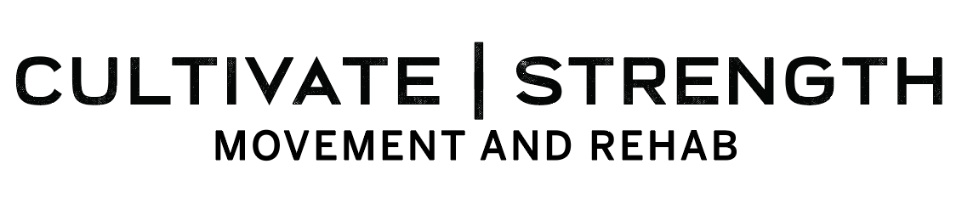This is the formula I use anytime I’m planning a full-body workout. Pick one from each category for every workout and if you have extra time throw in some accessory movements!

Squat
- Goblet squat
- Lunge
- Leg press
Hip hinge
- Glute bridge/hip thrust
- Back extensions
- Reverse hypers
- Deadlift
- Single leg deadlift
- Romanian deadlift
Push
- Push-up
- Bench press
- Overhead press
- Landmine press
Pull
- Dumbbell row
- Barbell row
- Cable row
- Landmine row
- Lat pulldown
Core
- Dead bug
- Plank
- Side plank
- Wood chops
- Pallof press
- Bird dog
- Loaded carries (suitcase carry, farmer’s carry, waiter’s carry, etc)

Accessory work (single joint movements)
- Calf raises
- Biceps curls
- Triceps pushdowns
- Pec flies
- Reverse flies
- A/Y/T’s
- Face-pulls
- Clamshells
- Skull crushers
- Leg extensions
- Hamstring curls
- Hip abduction
- Hip adduction

